UML DIAGRAMS

1. Use case diagrams

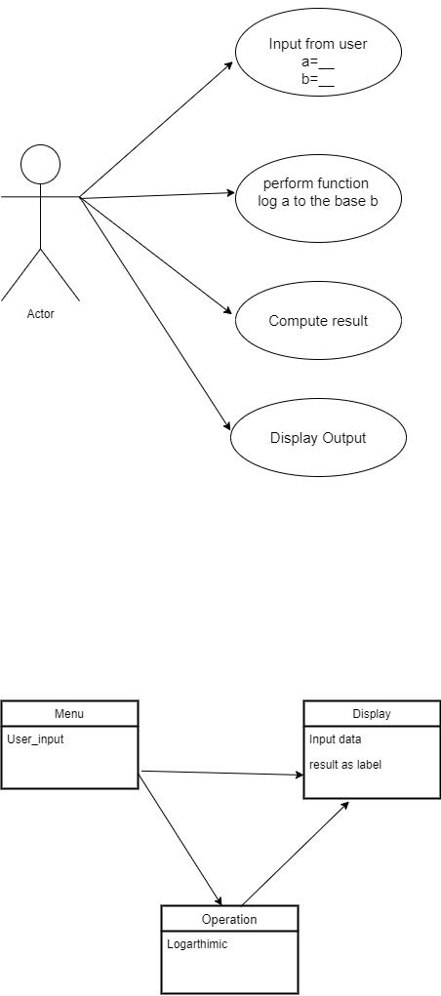

1. Class Diagram

